Student Name: Timothy Kaburu

Registration Number: 24/01455

Unit Code: DIT 503

Unit Title: PROJECT FOR INCOME AND EXPENSE MANAGEMENT

Supervisor: Clive Onsumu

Date Submitted: 7/17/2025

TABLE OF CONTENTS

**1. INTRODUCTION** 3

1.1 PURPOSE 3

1.2 DOCUMENT CONVENTIONS 4

1.3 INTENDED AUDIENCE AND READING SUGGESTIONS 4

1.4 PROJECT SCOPE 5

1.5 REFERENCES 6

**2. OVERALL DESCRIPTION** 7

2.1 PRODUCT PERSPECTIVE 7

2.2 PRODUCT FEATURES 8

**2.3 USER CLASSES AND CHARACTERISTICS** 8

2.4 OPERATING ENVIRONMENT 9

2.5 DESIGN AND IMPLEMENTATION CONSTRAINTS 10

2.6 USER DOCUMENTATION 10

2.7 ASSUMPTIONS AND DEPENDENCIES 11

**3. SYSTEM FEATURES** 12

3.1 FEATURE 1: USER AUTHENTICATION AND SESSION MANAGEMENT 12

3.2 FEATURE 2: INCOME/EXPENSE ENTRY MANAGEMENT 13

FUNCTIONAL REQUIREMENTS 14

3.3 FEATURE 3: TRANSACTION HISTORY VIEW 14

3.4 FEATURE 4: REAL-TIME SUMMARY DASHBOARD 15

3.5 FEATURE 5: LOGOUT AND SESSION DATA CLEARING 15

4. **EXTERNAL INTERFACE REQUIREMENTS** 17

4.1 USER INTERFACES 17

4.2 HARDWARE INTERFACES 17

4.3 SOFTWARE INTERFACES 17

4.4 COMMUNICATION INTERFACES 18

**5. OTHER NONFUNCTIONAL REQUIREMENTS** 18

5.1 PERFORMANCE REQUIREMENTS 18

5.2 SAFETY REQUIREMENTS 18

5.3 SECURITY REQUIREMENTS 19

5.4 SOFTWARE QUALITY ATTRIBUTES 19

**6. OTHER REQUIREMENTS** 20

**7. APPENDIX** 20

7.1 GLOSSARY 20

7.2 ANALYSIS MODELS 21

7.3 ISSUES LIST 21

PHOTOS ABOVE 22

# **1. INTRODUCTION**

# 1.1 PURPOSE

* This software requirements specification (srs) document provides a complete description of the requirements for the income & expense management, being developed for asad tech.
* The document details the system’s functional and non-functional requirements, interfaces, design constraints, and other essential information for developers, testers, and stakeholders.

# 1.2 DOCUMENT CONVENTIONS

* Shall indicates a mandatory requirement.
* Should indicates a recommended requirement.
* May indicates an optional requirement.
* All monetary values are assumed to be in kenyan shillings (ksh).
* User actions are indicated in italics.
* System responses are indicated in bold.

# 1.3 INTENDED AUDIENCE AND READING SUGGESTIONS

This document is intended for:

* Developers implementing the application.
* Testers planning the test cases.
* Project managers overseeing development.
* The admin and the staff review the system for educational purposes.

Reading suggestions:

* Developers: focus on section 3 (system features) and section 4 (interfaces).
* Testers: review section 3 (system features) and section 5 (nonfunctional requirements).
* Stakeholders: review sections 1 and 2 for an overview.

# 1.4 PROJECT SCOPE

* The income & expense management web application is a web-based tool designed for individual users (especially for the staff of asad tech) to record, view, and manage personal financial transactions in Kenyan shillings (ksh).
* It operates fully in the browser, requires no installation, and is suitable for both desktop and mobile use.

# 1.5 REFERENCES

* Ieee std 830-1998, ieee recommended practice for software requirements specifications
* Mdn web docs ([html](<https://developer.mozilla.org/en>
* Us/docs/web/html), [css](<https://developer.mozilla.org/en>
* Us/docs/web/css), [javascript]([https://developer.mozilla.org/en-us/docs/web/javascript)](https://developer.mozilla.org/en-US/docs/Web/JavaScript)))
* Iso/iec/ieee 29148:2018, systems and software engineering — life cycle processes — requirements engineering

# **2. OVERALL DESCRIPTION**

# 2.1 PRODUCT PERSPECTIVE

* This application is a standalone, client-side solution.
* It does not depend on external databases or servers.
* All data is stored in memory and lost upon page refresh or logout for privacy.

# 2.2 PRODUCT FEATURES

* Secure login with demo credentials.
* Add, edit, or delete income and expense transactions.
* View transaction history.
* Real-time calculation and display of total income, expenses, and balance.
* Logout and session data clearing.
* Responsive interface for mobile and desktop.

# **2.3 USER CLASSES AND CHARACTERISTICS**

|  |  |
| --- | --- |
| User | Characteristics |
| Asad tech admin | Responsible for the upkeep, configuration, and reliable operation of a company's computer systems, networks, and security systems. |
| Asad tech staff | Maintaining and troubleshooting it systems. |

# 2.4 OPERATING ENVIRONMENT

* Web browser: chrome, firefox, edge, safari (latest versions)
* Hardware: any device capable of running a modern browser (desktop, laptop, tablet, smartphone)
* Os: platform-independent (windows, macos, linux, android, ios)

# 2.5 DESIGN AND IMPLEMENTATION CONSTRAINTS

* No server-side components; all logic runs in browser.
* Data is not persisted (lost on refresh/logout).
* Only demo credentials permitted.
* Application must be written in html, css, javascript (es6+).

# 2.6 USER DOCUMENTATION

* In-application tooltips and instructions.
* Readme or user guide file included with the application.
* FAQ and troubleshooting section.

# 2.7 ASSUMPTIONS AND DEPENDENCIES

* User has access to a modern web browser with javascript enabled.
* Application is used for internal asad tech purposes.
* No need for multi-user support or persistent data storage.

# **3. SYSTEM FEATURES**

# 3.1 FEATURE 1: USER AUTHENTICATION AND SESSION MANAGEMENT

DESCRIPTION:

* User must log in using demo credentials to access the application.

STIMULUS/RESPONSE SEQUENCES

* User enters username and password*
* System verifies credentials; if correct, grants access; else shows error.
* User logs out
* System clears session data and returns to login page.

FUNCTIONAL REQUIREMENTS

* The system shall provide a login form.
* The system shall accept username: `user` and password: `1234`.
* The system shall prevent access to dashboard without authentication.
* The system shall destroy session data on logout.

# 3.2 FEATURE 2: INCOME/EXPENSE ENTRY MANAGEMENT

DESCRIPTION:

* User can add new income or expense entries.

STIMULUS/RESPONSE SEQUENCES

* User fills form with description, amount, and type; clicks “add entry”.
* System validates input, adds entry, updates summary and history.

# FUNCTIONAL REQUIREMENTS

* The system shall provide a form to add entries.
* The system shall require description, positive amount, and type.
* The system shall support entry of both income and expense.

# 3.3 FEATURE 3: TRANSACTION HISTORY VIEW

DESCRIPTION;

* User can view a list of all income and expense entries.

FUNCTIONAL REQUIREMENTS

* The system shall display entries in a table with columns: description, amount, type.
* The system shall show most recent entries first.
* The system shall allow the user to identify entry type via color coding.

# 3.4 FEATURE 4: REAL-TIME SUMMARY DASHBOARD

DESCRIPTION:

* User can see totals for income, expenses, and balance in real-time.

FUNCTIONAL REQUIREMENTS

* The system shall display three summary cards: income, expense, balance.
* The system shall update these values as entries are added or removed.

# 3.5 FEATURE 5: LOGOUT AND SESSION DATA CLEARING

DESCRIPTION :

* User may logout from the app, causing all session data to be cleared.

FUNCTIONAL REQUIREMENTS

* The system shall provide a visible logout button.
* The system shall clear all session data and return to login screen upon logout.

# 4. **EXTERNAL INTERFACE REQUIREMENTS**

# 4.1 USER INTERFACES

* Login page- username/password fields, error messages, demo credentials info.
* Dashboard-summary cards (income, expense, balance).
* Add entry form (description, amount, type).
* Transaction history table.
* Logout button.
* Responsive design for desktop and mobile.

# 4.2 HARDWARE INTERFACES

* No special hardware required.
* Runs on standard pcs, laptops, tablets, and smartphones.

# 4.3 SOFTWARE INTERFACES

* Runs in client browser only.
* No api, backend, or external database required.

# 4.4 COMMUNICATION INTERFACES

* No network communication post-load.
* No data sent or received from external systems.

# **5. OTHER NONFUNCTIONAL REQUIREMENTS**

# 5.1 PERFORMANCE REQUIREMENTS

* App shall load within 2 seconds on a typical network.
* Entry addition and summary updates must be instantaneous
* App shall support at least 100 entries in a session without slowdown.

# 5.2 SAFETY REQUIREMENTS

* App shall not store sensitive information beyond session.
* App shall warn users that data will be lost on refresh or logout.

# 5.3 SECURITY REQUIREMENTS

* Only demo credentials accepted.
* No personal data stored persistently.
* All code runs in browser; no external data exposure.

# 5.4 SOFTWARE QUALITY ATTRIBUTES

* Usability- intuitive ui, color cues, large buttons.
* Reliability- accurate calculations, robust validation.
* Portability- works across major browsers and devices.
* Maintainability-well-structured, commented, modular code.
* Accessibility- supports keyboard navigation and color contrast.

**6. OTHER REQUIREMENTS**

* App shall use ksh as the currency in all displays.
* App may include tooltips for improved usability.

# **7. APPENDIX**

# 7.1 GLOSSARY

* Entry- a single income or expense record.
* Income- money received.
* Expense- money spent.
* Balance- income minus expense.
* Dashboard- main screen showing summaries and history.

# 7.2 ANALYSIS MODELS

* Flowcharts-see system flow diagrams in project documentation.
* UI mockups- refer to wireframes in design documentation.

State diagrams- login → dashboard → add/edit/logout → login

# 7.3 ISSUES LIST

|  |  |  |
| --- | --- | --- |
| ID | ISSUE DESCRIPTION | STATUS |
| 1 | NO DATA PERSISTENCE | KNOWN |
| 2 | NO EDIT/DELETE FOR ENTRIES | PLANNED |
| 3 | SINGLE-USER MODE ONLY | ACCEPTED |
| 4 | NO EXPORT/IMPORT | PLANNED |
| 5 | NO PASSWORD RESET | ACCEPTED |

# PHOTOS ABOVE

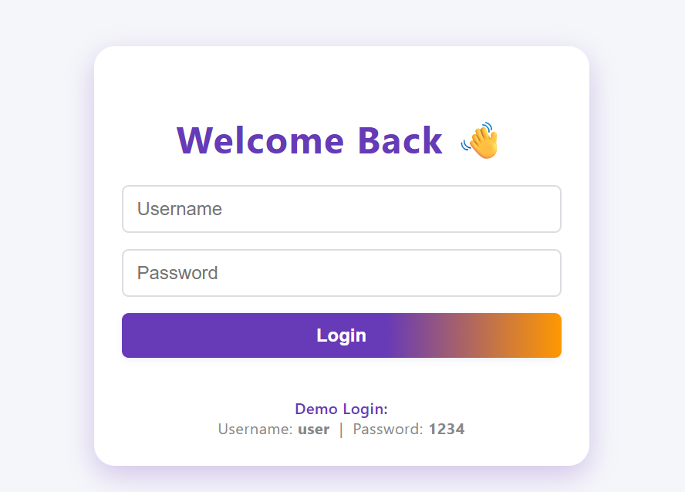

FIGURE 1.1 THE LOGIN PAGE

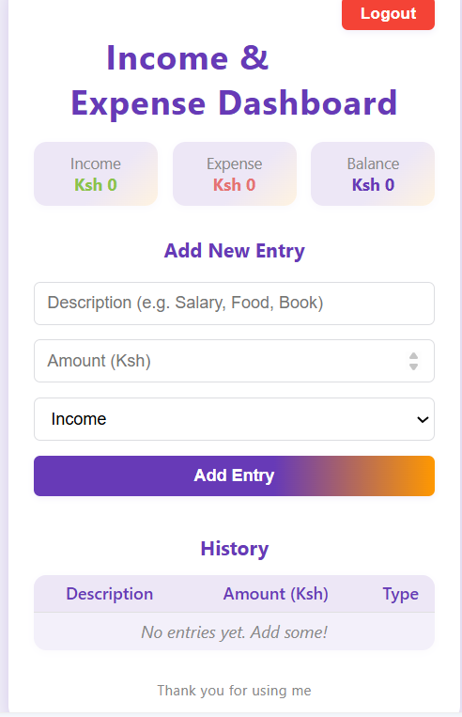

FIGURE 1.2 DASHBOARD

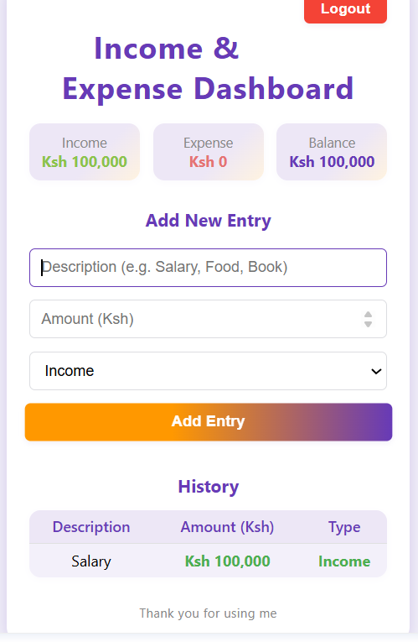

FIGURE 1.3 INCOME ENRTY

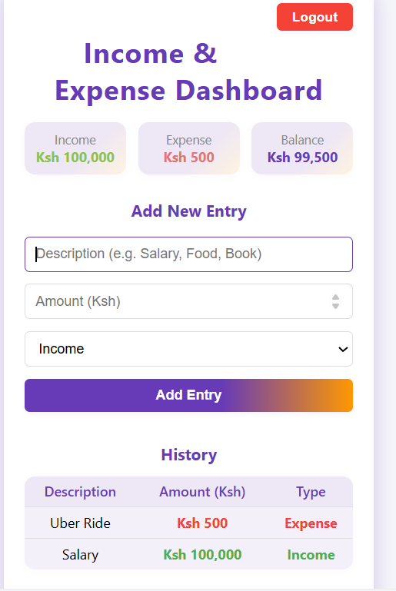FIGURE 1.4 EXPENSE ENTRY